# File permissions in Linux

## Project description

[Describe what you accomplish through Linux commands.]

This project assesses file permissions among linux users. There are three types of users in this project include; **users** who are owners of files or directories, **groups** who are a subdivision of of members to where the user belongs then **others** who are any other users on the linux system. In this project, we check permissions for all users and modify permissions according to authorized roles.

## Check file and directory details

To check the permissions we use the ls command with either -l or -a based on whether the files or directories are hidden or not. The commands are **ls -l** and **ls -a** to view hidden files.

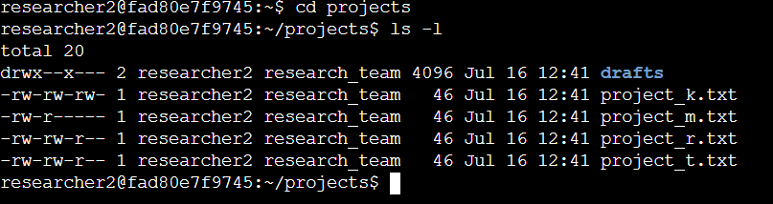

## Describe the permissions string

The basic permission string in Linux has 10 strings of characters. For Example we can have a projects directory with the following file permissions; **drwxrw-r-x** . The first letter symbolizes the file or directory. The second character to fourth represents the the permissions of the User of the three types of users. The fifth to seventh character represents the group permissions and the eighth character to tenth represents the the other user group. In the permissions string, r stands for for read, w for write and x for execute. Users have permissions based on these characters. A dash represents denial of that particular permission to that user.

## Change file permissions

In order to change permissions on a system, we use the chmod command. This command is then followed by the user group and an operand depending on whether we are denying or allowing the permissions. Example of the directory given above;

Drwxrw-r-x. If we enter a command chmod o-x projects we are stripping off the **Other** user of the execution permission.



## Change file permissions on a hidden file

Hidden files in Linux do not show when you enter the ls command. Usings the ls -a exposes the hidden files which are denoted by a period before the file name. The same chmod command is used to modify the permissions on the file.



## Change directory permissions

Directory permissions work in the same way as file permissions on various groups.

## Summary

In Linux, it is imperative to ensure that that file permissions are assigned correctly. Wrongly assigned permissions can lead to deletion of modification of important files.